|  |  |
| --- | --- |
|  | Assignment 03 |
|  |  |
|  | Parth Chandgadhiya 300986134  COMP 214 - [Sec 12]  12/7/18 |

Table of Contents

DDPAY_SP Procedure: 2

DDPAY_SP Output: 2

Procedure: 3

Executing Procedure: 4

DDCKPAY_SP Procedure: 4

DDCKPAY_SP Output: 4

1. Output for ID 104 and Payment Amount $20 4

2. Output for ID 104 and Payment Amount $25 5

3. a pledge ID for a pledge that does not have monthly payments associated with it. 6

Procedure: 6

Executing Procedure: 7

1.) Executing Procedure for ID 104 and Payment Amount $25 7

2.) Executing Procedure for ID 104 and Payment Amount $20 7

3.) Executing Procedure for a pledge ID for a pledge that does not have monthly payments associated with it. 7

DDCHKBAL_SP Procedure: 8

DDCHKBAL_SP Output: 9

1) For Pledge id 107 9

2) For Pledge id 104 9

Procedure: 10

Executing Procedure: 11

1). Executing Procedure for Pledge Id 104 11

2). Executing Procedure for Pledge Id 104 11

SHOP_QUERY_PKG Package and Body: 11

SHOP_QUERY_PKG Output: 12

SHOP_QUERY_PKG pacakage: 13

Executing SHOP_QUERY_PKG: 14

TAX_RATE_PKG Package: 14

TAX_RATE_PKG Invoked: 15

Package: 15

Invoking Package: 15

LOGIN_PKG Package and Body: 16

LOGIN_PKG Output: 17

LOGIN_PKG Package: 17

LOGIN_PKG Invoked: 18

PART A

Answer 01

# DDPAY_SP Procedure:

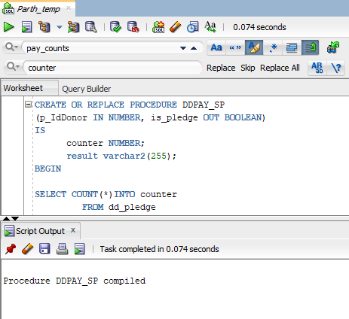

# DDPAY_SP Output:

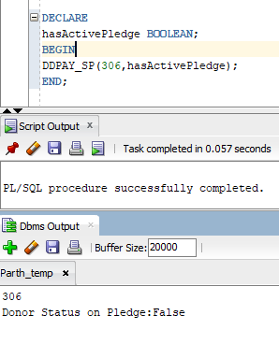

## Procedure:

CREATE OR REPLACE PROCEDURE DDPAY_SP

(p_IdDonor IN NUMBER, is_pledge OUT BOOLEAN)

IS

counter NUMBER;

result varchar2(255);

BEGIN

SELECT COUNT(*)INTO counter

FROM dd_pledge

WHERE iddonor = counter AND paymonths > 1;

IF counter > 1 THEN

is_pledge := TRUE;

ELSE is_pledge := FALSE;

END IF;

DBMS_OUTPUT.PUT_LINE(p_Iddonor);

DBMS_OUTPUT.PUT_LINE

(

'Donor Status on Pledge:' ||

CASE is_pledge

WHEN TRUE THEN 'True'

ELSE 'False'

END

);

END DDPAY_SP;

## Executing Procedure:

DECLARE

hasActivePledge BOOLEAN;

BEGIN

DDPAY_SP(306,hasActivePledge);

END;

Answer 02

# DDCKPAY_SP Procedure:

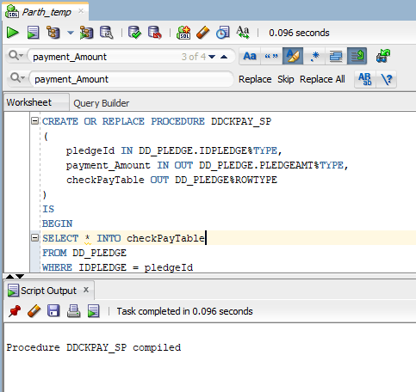

# DDCKPAY_SP Output:

## 1. Output for ID 104 and Payment Amount $20

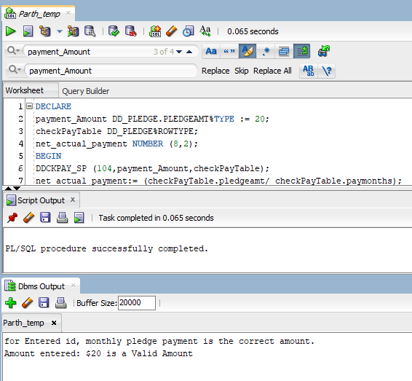

## 2. Output for ID 104 and Payment Amount $25

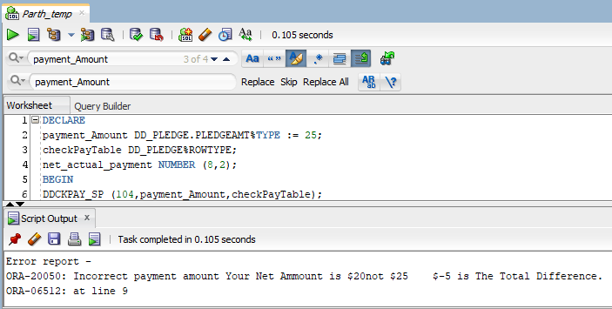

## 3. a pledge ID for a pledge that does not have monthly payments associated with it.

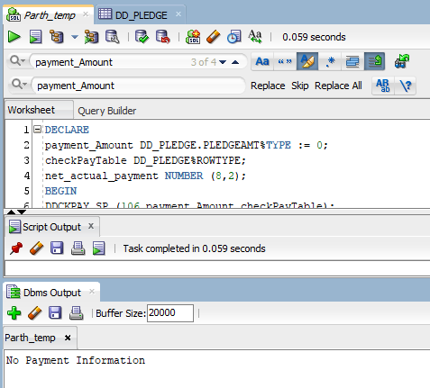

## Procedure:

CREATE OR REPLACE PROCEDURE DDCKPAY_SP

(

pledgeId IN DD_PLEDGE.IDPLEDGE%TYPE,

payment_Amount IN OUT DD_PLEDGE.PLEDGEAMT%TYPE,

checkPayTable OUT DD_PLEDGE%ROWTYPE

)

IS

BEGIN

SELECT * INTO checkPayTable

FROM DD_PLEDGE

WHERE IDPLEDGE = pledgeId

AND PAYMONTHS >0;

IF SQL%NOTFOUND THEN

DBMS_OUTPUT.PUT_LINE ('No Payment Information');

END IF;

END;

## Executing Procedure:

### 1.) Executing Procedure for ID 104 and Payment Amount $25

DECLARE

payment_Amount DD_PLEDGE.PLEDGEAMT%TYPE := 25;

checkPayTable DD_PLEDGE%ROWTYPE;

net_actual_payment NUMBER (8,2);

BEGIN

DDCKPAY_SP (104,payment_Amount,checkPayTable);

net_actual_payment:= (checkPayTable.pledgeamt/ checkPayTable.paymonths);

IF payment_Amount != net_actual_payment THEN

RAISE_APPLICATION_ERROR(-20050, 'Incorrect payment amount Your Net Ammount is $' ||net_actual_payment || 'not $' || payment_Amount

|| ' $'||( net_actual_payment - payment_Amount) ||' is The Total Difference.');

ELSE

DBMS_OUTPUT.PUT_LINE('for Entered id, monthly pledge payment is the correct amount.');

END IF;

DBMS_OUTPUT.put_line('Amount entered: $' || net_actual_payment || ' is a Valid Amount');

END;

### 2.) Executing Procedure for ID 104 and Payment Amount $20

DECLARE

payment_Amount DD_PLEDGE.PLEDGEAMT%TYPE := 25;

checkPayTable DD_PLEDGE%ROWTYPE;

net_actual_payment NUMBER (8,2);

BEGIN

DDCKPAY_SP (104,payment_Amount,checkPayTable);

net_actual_payment:= (checkPayTable.pledgeamt/ checkPayTable.paymonths);

IF payment_Amount != net_actual_payment THEN

RAISE_APPLICATION_ERROR(-20050, 'Incorrect payment amount Your Net Ammount is $' ||net_actual_payment || 'not $' || payment_Amount

|| ' $'||( net_actual_payment - payment_Amount) ||' is The Total Difference.');

ELSE

DBMS_OUTPUT.PUT_LINE('for Entered id, monthly pledge payment is the correct amount.');

END IF;

DBMS_OUTPUT.put_line('Amount entered: $' || net_actual_payment || ' is a Valid Amount');

END;

### 3.) Executing Procedure for a pledge ID for a pledge that does not have monthly payments associated with it.

DECLARE

payment_Amount DD_PLEDGE.PLEDGEAMT%TYPE := 0;

checkPayTable DD_PLEDGE%ROWTYPE;

net_actual_payment NUMBER (8,2);

BEGIN

DDCKPAY_SP (106,payment_Amount,checkPayTable);

net_actual_payment:= (checkPayTable.pledgeamt/ checkPayTable.paymonths);

IF payment_Amount != net_actual_payment THEN

RAISE_APPLICATION_ERROR(-20050, 'Incorrect payment amount Your Net Ammount is $' ||net_actual_payment || 'not $' || payment_Amount

|| ' $'||( net_actual_payment - payment_Amount) ||' is The Total Difference.');

ELSE

DBMS_OUTPUT.PUT_LINE('for Entered id, monthly pledge payment is the correct amount.');

END IF;

DBMS_OUTPUT.put_line('Amount entered: $' || net_actual_payment || ' is a Valid Amount');

END;

Answer 03

# DDCHKBAL_SP Procedure:

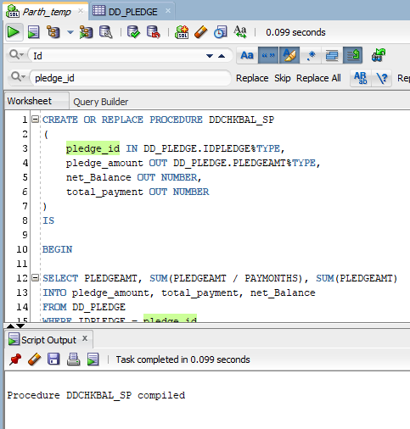

# DDCHKBAL_SP Output:

## 1) For Pledge id 107

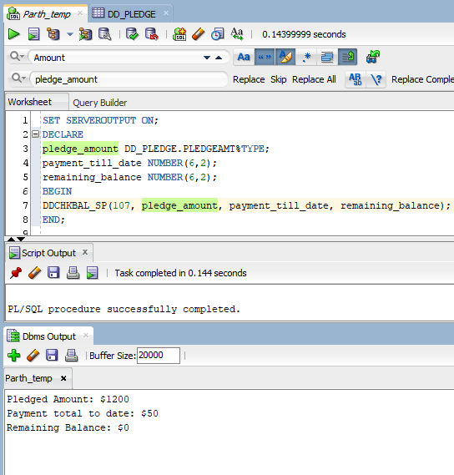

## 2) For Pledge id 104

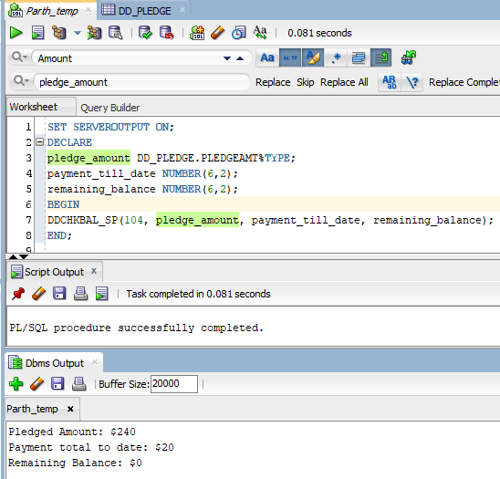

## Procedure:

create or replace PROCEDURE DDCHKBAL_SP

(

pledge_id IN DD_PLEDGE.IDPLEDGE%TYPE,

pledge_amount OUT DD_PLEDGE.PLEDGEAMT%TYPE,

net_Balance OUT NUMBER,

total_payment OUT NUMBER

)

IS

BEGIN

SELECT PLEDGEAMT, SUM(PLEDGEAMT / PAYMONTHS), SUM(PLEDGEAMT)

INTO pledge_amount, total_payment, net_Balance

FROM DD_PLEDGE

WHERE IDPLEDGE = pledge_id

GROUP BY PLEDGEAMT;

net_Balance := net_Balance - pledge_amount;

DBMS_OUTPUT.PUT_LINE('Pledged Amount: $' || pledge_amount);

DBMS_OUTPUT.PUT_LINE('Payment total to date: $'|| total_payment);

DBMS_OUTPUT.PUT_LINE('Remaining Balance: $' || net_Balance);

END;

## Executing Procedure:

### 1). Executing Procedure for Pledge Id 104

SET SERVEROUTPUT ON;

DECLARE

pledge_amount DD_PLEDGE.PLEDGEAMT%TYPE;

payment_till_date NUMBER(6,2);

remaining_balance NUMBER(6,2);

BEGIN

DDCHKBAL_SP(107, pledge_amount, payment_till_date, remaining_balance);

END;

### 2). Executing Procedure for Pledge Id 104

SET SERVEROUTPUT ON;

DECLARE

pledge_amount DD_PLEDGE.PLEDGEAMT%TYPE;

payment_till_date NUMBER(6,2);

remaining_balance NUMBER(6,2);

BEGIN

DDCHKBAL_SP(104, pledge_amount, payment_till_date, remaining_balance);

END;

PART B

Answer 01

# SHOP_QUERY_PKG Package and Body:

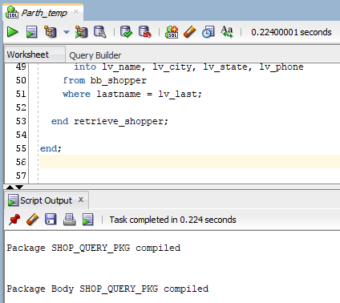

# SHOP_QUERY_PKG Output:

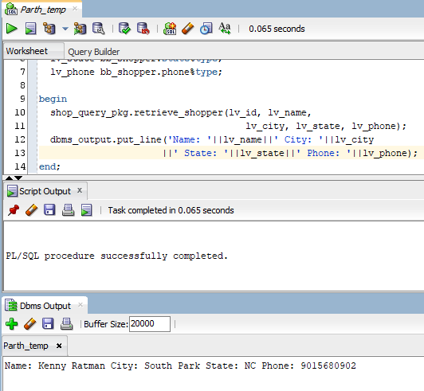

## SHOP_QUERY_PKG pacakage:

create or replace package shop_query_pkg is

procedure retrieve_shopper

(lv_id in bb_shopper.idshopper%type,

lv_name out varchar,

lv_city out bb_shopper.city%type,

lv_state out bb_shopper.state%type,

lv_phone out bb_shopper.phone%type);

procedure retrieve_shopper

(lv_last in bb_shopper.lastname%type,

lv_name out varchar,

lv_city out bb_shopper.city%type,

lv_state out bb_shopper.state%type,

lv_phone out bb_shopper.phone%type);

end;

create or replace package body shop_query_pkg is

procedure retrieve_shopper

(lv_id in bb_shopper.idshopper%type,

lv_name out varchar,

lv_city out bb_shopper.city%type,

lv_state out bb_shopper.state%type,

lv_phone out bb_shopper.phone%type)

is

begin

select firstname||' '||lastname, city,

state, phone

into lv_name, lv_city, lv_state, lv_phone

from bb_shopper

where idshopper = lv_id;

end retrieve_shopper;

procedure retrieve_shopper

(lv_last in bb_shopper.lastname%type,

lv_name out varchar,

lv_city out bb_shopper.city%type,

lv_state out bb_shopper.state%type,

lv_phone out bb_shopper.phone%type)

is

begin

select firstname||' '||lastname, city,

state, phone

into lv_name, lv_city, lv_state, lv_phone

from bb_shopper

where lastname = lv_last;

end retrieve_shopper;

end;

## Executing SHOP_QUERY_PKG:

declare

lv_id number := 23;

lv_last bb_shopper.lastname%type := 'Ratman';

lv_name varchar2(25);

lv_city bb_shopper.city%type;

lv_state bb_shopper.state%type;

lv_phone bb_shopper.phone%type;

begin

shop_query_pkg.retrieve_shopper(lv_id, lv_name,

lv_city, lv_state, lv_phone);

dbms_output.put_line('Name: '||lv_name||' City: '||lv_city

||' State: '||lv_state||' Phone: '||lv_phone);

end;

Answer 02

# TAX_RATE_PKG Package:

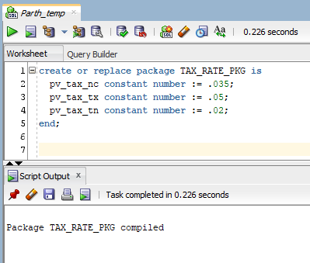

# TAX_RATE_PKG Invoked:

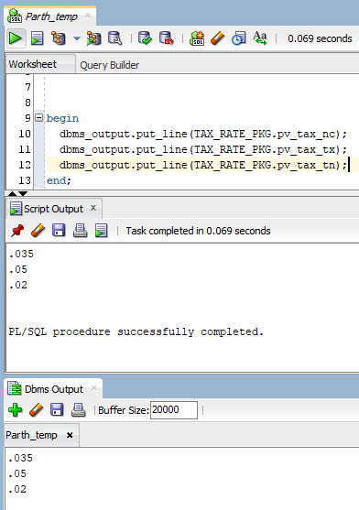

## Package:

create or replace package TAX_RATE_PKG is

pv_tax_nc constant number := .035;

pv_tax_tx constant number := .05;

pv_tax_tn constant number := .02;

end;

## Invoking Package:

begin

dbms_output.put_line(TAX_RATE_PKG.pv_tax_nc);

dbms_output.put_line(TAX_RATE_PKG.pv_tax_tx);

dbms_output.put_line(TAX_RATE_PKG.pv_tax_tn);

end;

Answer 03

# LOGIN_PKG Package and Body:

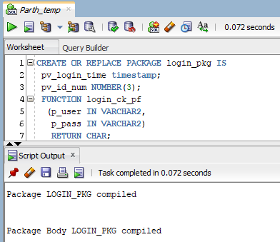

# LOGIN_PKG Output:

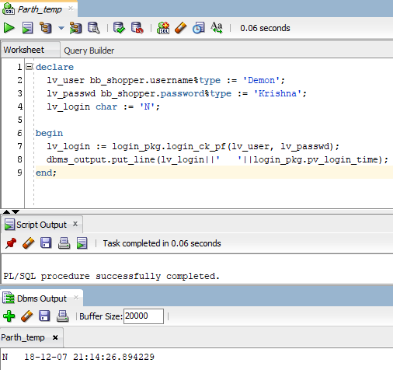

## LOGIN_PKG Package:

CREATE OR REPLACE PACKAGE login_pkg IS

pv_login_time timestamp;

pv_id_num NUMBER(3);

FUNCTION login_ck_pf

(p_user IN VARCHAR2,

p_pass IN VARCHAR2)

RETURN CHAR;

END;

CREATE OR REPLACE PACKAGE BODY login_pkg IS

FUNCTION login_ck_pf

(p_user IN VARCHAR2,

p_pass IN VARCHAR2)

RETURN CHAR

IS

lv_ck_txt CHAR(1) := 'N';

lv_id_num NUMBER(5);

BEGIN

SELECT idShopper

INTO lv_id_num

FROM bb_shopper

WHERE username = p_user

AND password = p_pass;

lv_ck_txt := 'Y';

pv_id_num := lv_id_num;

RETURN lv_ck_txt;

EXCEPTION

WHEN NO_DATA_FOUND THEN

RETURN lv_ck_txt;

END login_ck_pf;

begin

select systimestamp

into pv_login_time

from dual;

END;

## LOGIN_PKG Invoked:

declare

lv_user bb_shopper.username%type := 'Demon';

lv_passwd bb_shopper.password%type := 'Krishna';

lv_login char := 'N';

begin

lv_login := login_pkg.login_ck_pf(lv_user, lv_passwd);

dbms_output.put_line(lv_login||' '||login_pkg.pv_login_time);

end;

**THE END**